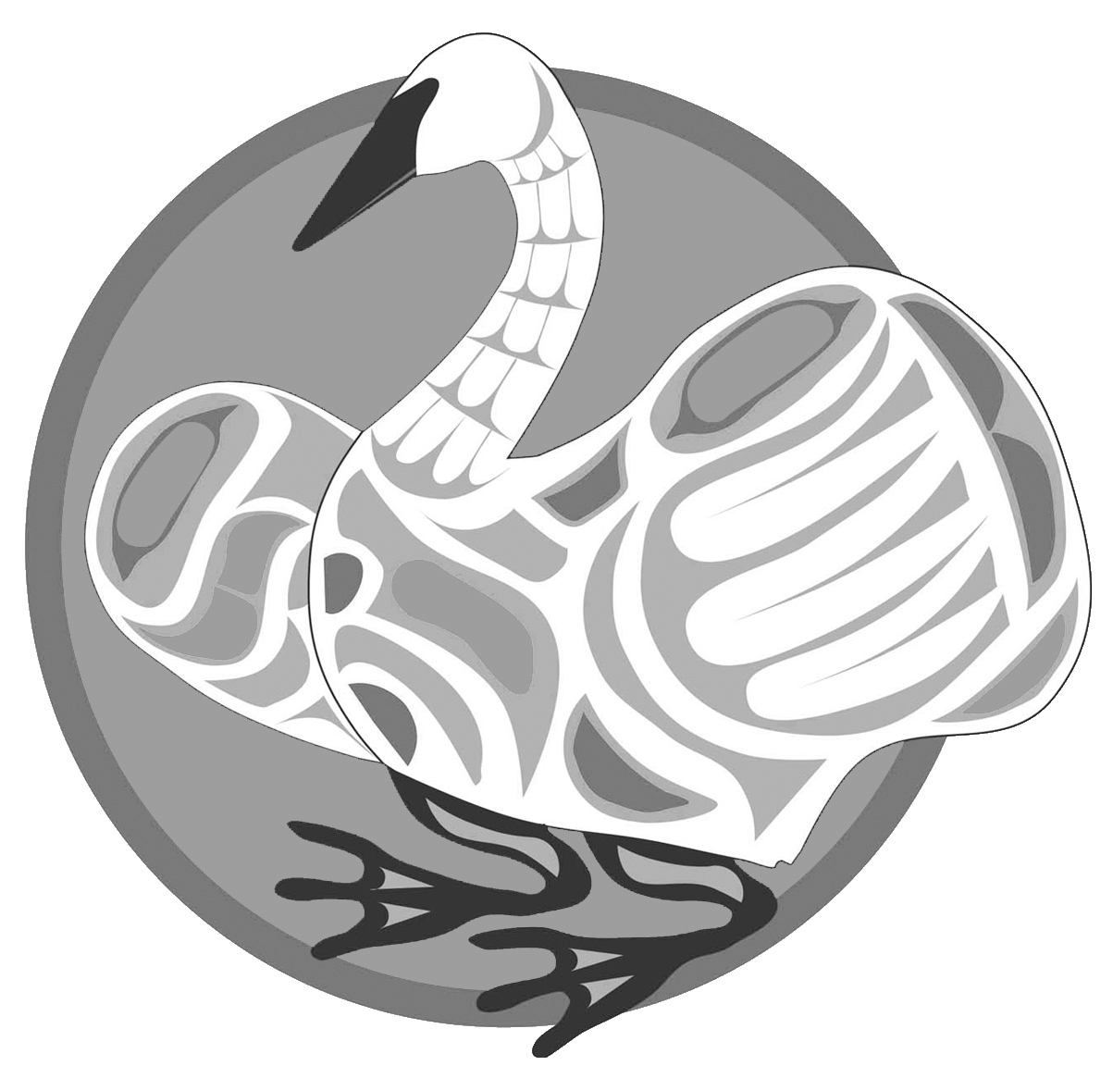
Northwest Swan Conservation Association
BECOME A MEMBER – help support swans
If you wish to email the form in, use the INSERT key before typing

Join NWSCA and make a difference for the future of our native Trumpeter and Tundra Swans! When you join NWSCA, you lend your voice to the growing list of those working to assure our wild swans continue to grace our skies, wetlands and agricultural fields in Washington State.
NWSCA depends upon private donations to continue our work. You can help! Donations are tax deductible for U. S. citizens. You will receive an acknowledgment in the mail for your tax records.
You can use this membership form to join Northwest Swan Conservation Association.
Membership Categories and Annual Dues (check one)
Individual $ 25 ____ Patron $ 250 ____
Family $ 35 ____ Benefactor $ 500 ____
Ally $ 100 ____ Swan Steward $1,000 ____
Other $_________________

Donation: _______________________

Name:_________________________________________________________

Address:_______________________________________________________

City_________________________________ Zip________________

Telephone: (_______)______________________

E-mail _______________________________________________________
You may also join us by visiting our website and using the donate button to become a member or make a donation. www.nwswans.org
Please make checks payable to NWSCA.
If you choose to mail this in, send this form and your check to
Northwest Swan Conservation Association
PMB 272
914 – 164th St SE
Mill Creek, WA 98012

